**INTRODUCTION:**

**MUTUAL INDUCTION**

Self-induction in a coil or conductor manifests as an induced back electromotive force (emf), which is generated when the magnetic field created by the current flow interacts with the coil or conductor itself. This interaction occurs as the magnetic flux lines, produced by the expanding and contracting magnetic field, cut through the coil's windings. When the current flowing through the coil changes, it creates a varying magnetic field around the coil. As these flux lines expand and contract, they induce an emf within the same coil, opposing the change in current according to Lenz's Law. This phenomenon is a direct consequence of the coil's inductance, which resists changes in the current flowing through it.

If the flux lines from one coil intersect the windings of another nearby coil, a voltage is induced in that second coil as well. The magnitude of the induced emf in this scenario depends on the relative positioning of the two coils and the number of turns in the secondary coil. The coil in which the magnetic flux originates is referred to as the primary coil, and the one in which the emf is induced is called the secondary coil. The current flowing through the primary coil is termed the primary current. If the secondary coil is connected to a load, allowing current to flow through it, this current is known as the secondary current. The efficiency of this induction process is influenced by how closely the coils are coupled and their physical alignment, which determines the extent to which the magnetic flux of one coil can link with the other.

The flow of current in the secondary coil generates its own magnetic field, which can, in turn, induce a voltage back into the primary coil. This interplay between the primary and secondary coils, where each induces emf in the other through their respective magnetic fields, exemplifies the concept of mutual inductance. Mutual inductance is effectively the measure of how well two coils are magnetically coupled and can influence each other through their magnetic fields. It is a crucial principle in the functioning of transformers and other electromagnetic devices. Transformers, for example, rely on mutual inductance to transfer electrical energy efficiently between circuits, enabling the step-up or step-down of voltage levels in power transmission. Understanding mutual inductance is essential for designing and optimizing these devices, ensuring efficient energy transfer and minimal losses.

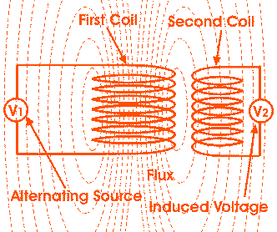

**AIM :**

To study the electromagnetic mutual induction through making a led blub to

glow by inducing current on it.

**THEORY:**

Mutual inductance is the main operating principle of generators, motors, and transformers. It occurs when two coils are brought close together and the magnetic field in one coil links with the other, generating voltage in the second coil. The constant of proportionality between the induced electromotive force (emf) in the second coil and the current passing through the first coil is called mutual inductance. The SI unit of mutual inductance is Henry (H), the same as that of self-inductance. Mutual inductance depends on various geometrical factors of the two coils, such as the number of turns and their radii. This concept, although simple in theory and understandable through the use of two or more coils, was first described by American scientist Joseph Henry in the 19th century.

Mutual inductance is regarded as one of the inherent properties of a coil or conductor within a circuit. If the current in one coil changes over time, an emf is induced in another coil. Oliver Heaviside introduced the term inductance in 1886, further formalizing the understanding of this property. Mutual inductance underpins the operation of many electrical components that function via magnetic fields, with transformers being a fundamental example. Transformers rely on mutual inductance to efficiently transfer electrical energy between circuits, making it possible to step up or step down voltage levels for various applications.

However, mutual inductance has its challenges, primarily inductive leakage, where the magnetic field of one coil does not entirely link with the other coil, thus interrupting efficient operation. This leakage can diminish the performance of devices relying on electromagnetic induction. To mitigate such issues, electrical screening and optimal positioning of the coils are necessary to ensure maximum mutual coupling and minimal energy loss. The precise alignment of the coils in the circuit is crucial for achieving the desired amount of mutual inductance, thereby enhancing the efficiency and 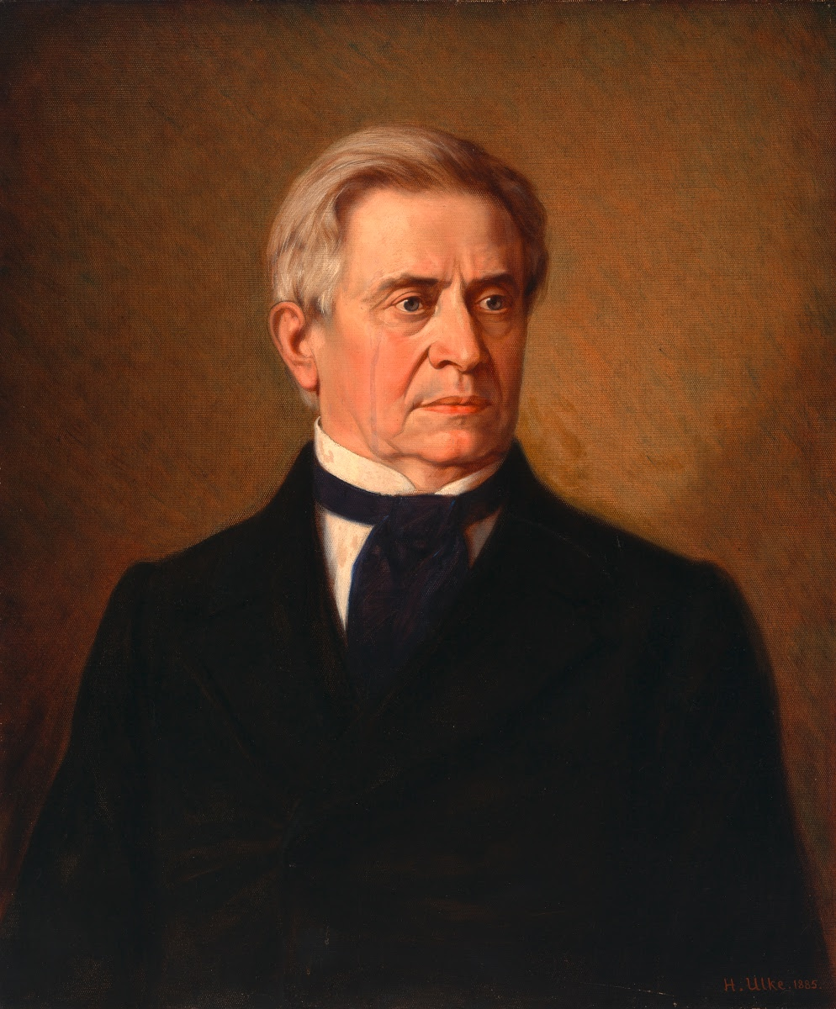functionality of the electrical systems involved.

JOSEPH HENRY

**Mutual Inductance of Two Coils:**

The mutual inductance of two coils can be increased by placing them on a soft iron core or by increasing the number of turns in each coil. When the coils are tightly wound around a soft iron core, unity coupling exists between them, meaning the magnetic coupling is nearly perfect, and the leakage of magnetic flux is minimal. The soft iron core enhances the magnetic field strength, thereby improving the mutual inductance. By increasing the number of turns in both coils, the magnetic linkage between them is also enhanced, resulting in a higher induced electromotive force (emf).

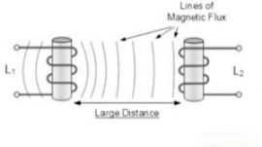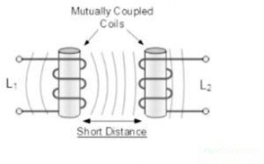

Figure 1.3 Figure 1.4

If the distance between the two coils is short, the magnetic flux produced in the first coil interacts with all the turns of the second coil. This close proximity ensures that a significant amount of the magnetic field from the primary coil cuts through the secondary coil, resulting in a large emf and, consequently, a high mutual inductance. The magnetic coupling in this scenario is strong because the entire magnetic field generated by the primary coil effectively links with the secondary coil, maximizing the induced emf.

Conversely, if the two coils are positioned farther apart or at different angles relative to each other, the magnetic flux from the first coil interacts less effectively with the turns of the second coil. This results in a weaker magnetic linkage and a smaller induced emf in the secondary coil, leading to a lower mutual inductance. The increased distance and misalignment cause significant magnetic flux leakage, reducing the efficiency of energy transfer between the coils. This weak coupling demonstrates the importance of coil placement and alignment in optimizing mutual inductance for various applications.

### **Applications:**

The **applications of mutual inductance** are :

* Transformer
* Electric Motors
* Generators
* Other electrical devices, which work with a magnetic field.
* Used in calculation of eddy currents
* Digital signal processing

**MATERIALS REQUIRED:**

1. Copper wires
2. Solenoid
3. Push Switch
4. Battery
5. Compact fluorescent lamps (CFLs)

**PROCEDURE:**

1. Connect copper wires to both terminals of the battery.

2. Attach the switch to the wire from the positive terminal of the battery.

3. Carefully connect the solenoid to the switch, completing Circuit A.

4. Construct Circuit B and connect the copper wire to another inductor.

5. Join the inductor to the compact fluorescent lamps (CFLs).

6. Close both circuits.

7. Position Circuits A and B near each other, separated by a short distance.

8. Verify all connections for security and correctness.

9. Test the setup by closing the switch in Circuit A.

10. Observe the CFLs in Circuit B to check for illumination.

11. Fine-tune the setup as needed, adjusting the distance and orientation between them.

12. Repeat testing and adjustments until desired results are achieved.

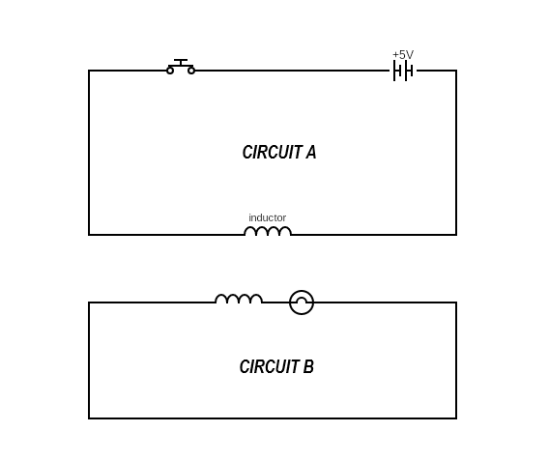

**OBSERVATION:**

* Upon closing the switch, the circuit becomes operational, facilitating the flow of current along the copper wire. This action triggers the solenoid in Circuit A to generate a magnetic field, which, in turn, induces a corresponding current in the neighboring solenoid of Circuit B. This process exemplifies the principle of electromagnetic induction, wherein a changing magnetic field induces an electromotive force (emf) in nearby conductors.
* The induced current in Circuit B, generated by the mutual inductance with Circuit A, finds its path through the solenoid, effectively energizing the compact fluorescent lamp (CFL) connected to Circuit B. As the current flows through the CFL, it excites the phosphor coating inside the lamp, producing visible light. This illumination serves as a tangible manifestation of the energy transfer facilitated by mutual inductance between the two circuits.
* Conversely, when the separation between the circuits is increased to a considerable distance, the strength of the magnetic coupling diminishes. This reduction in magnetic coupling results in a weakened induction effect between the circuits, rendering the transfer of current less efficient. Consequently, the induction of current in Circuit B becomes insufficient to power the CFL, leading to a lack of illumination. This observation underscores the critical role of proximity and magnetic coupling in facilitating effective mutual inductance between electrical circuits.

**PRECAUTIONS:**

**Safety First:** Prioritize safety by ensuring circuits are disconnected from power sources before handling. Use insulated tools and wear appropriate personal protective equipment to prevent electric shocks.

**Check Circuit Ratings:** Verify that components are rated for the intended application to avoid overloading circuits or exceeding voltage and current limits, which could lead to damage or injury.

**Secure Connections:** Double-check all connections to ensure they are tight and free from loose wires or components, reducing the risk of electrical arcing or circuit failure.

**Enclose Circuits:** Use protective casings or enclosures to prevent accidental contact with live components, and insulate exposed wires to minimize the risk of short circuits or electrical hazards.

**Monitor for Overheating:** Keep an eye out for signs of overheating, such as burning smells or discoloration, and ensure proper ventilation and cooling for components prone to generating heat.

**Position Components Carefully:** Place coils or solenoids securely and away from heat sources or electromagnetic interference to ensure proper operation.

**Supervise Experiments:** Conduct experiments under the supervision of experienced individuals, especially when working with high-voltage circuits or complex setups.

**Emergency Preparedness:** Familiarize yourself with emergency procedures, including how to safely disconnect power sources and respond to accidents or injuries.

**CONCLUSION:**

In conclusion, the principles of electromagnetic induction are fundamental to various electrical devices and applications, facilitating the transfer of energy between circuits through the interaction of magnetic fields. Through experiments involving coils, solenoids, and circuits, we have observed firsthand how changes in magnetic flux induce electromotive forces (emf) in nearby conductors, demonstrating the phenomenon of mutual inductance. By carefully constructing and manipulating circuits, we can control the transfer of energy and explore the relationship between current, voltage, and magnetic fields.

However, while electromagnetic induction offers numerous benefits, it also poses certain challenges and risks. It is crucial to prioritize safety at all times, ensuring circuits are properly insulated, components are securely connected, and experiments are conducted under supervision. Additionally, attention must be paid to circuit design and component ratings to prevent overloading or damaging equipment.

Looking ahead, further research and experimentation in the field of electromagnetic induction hold promise for advancements in various industries, including power generation, telecommunications, and transportation. By gaining a deeper understanding of these principles and their practical applications, we can continue to innovate and develop new technologies to meet the evolving needs of society.

In summary, electromagnetic induction is a powerful phenomenon with wide-ranging implications, shaping the way we harness and utilize electrical energy. Through hands-on experimentation and adherence to safety protocols, we can unlock its full potential and drive progress in the field of electrical engineering.

**BIBILIOGRAPHY:**

1) [www.byjus.com](http://www.byjus.com)

2) [www.elprocus.com](http://www.elprocus.com)

3) phys.libretexts.org  
4) www.dreamstime.com